Minor Data Driven Decision Making in Business
Data Science Job Opportunities and Salaries Across U.S. States
Individual portfolio 2023

Dennis Hazelaar (student)
11-6-2023

Table of contents
Intoduction 2
Crisp-DM 3
Business Understanding: 4
Data understanding: 4
Data preparation 4
Modeling 5
Evaluation and deployment 5
The analysis 6
Conclusion 9

Introduction
Since embarking on this minor, my journey into coding and data analysis has been an immensely enjoyable experience. The thrill of uncovering patterns and insights from raw data has ignited a passion within me. In fact, I have already secured a part-time job that aligns perfectly with my pursuit of this minor. As an aspiring data science professional, it is crucial for me to gain profound insights into the regions that provide the most conducive environment for individuals in this field.
Initially, my intention was to analyze the Netherlands, a country known for its technological advancements and innovation-friendly atmosphere. However, to my disappointment, I discovered a dearth of available data for conducting a comprehensive study. Undeterred by this setback, I quickly redirected my research focus to the United States, a nation renowned as a global powerhouse in technology and data-driven innovation.
To conduct my analysis, I adopted the CRISP-DM model, a widely recognized framework for data mining projects. This structured approach guided me through the steps of defining objectives, collecting, and preparing data, and analyzing it to determine the most conducive region for data science professionals. The model ensured a systematic and comprehensive exploration the most lucrative state for data science professionals.

Crisp-DM
The Cross-Industry Standard Process for Data Mining (CRISP-DM) is a widely used model that helps individuals like myself tackle data mining projects. It consists of six main phases: Business Understanding, Data Understanding, Data Preparation, Modeling, Evaluation, and Deployment.
CRISP-DM is an iterative process, allowing me to revisit previous phases if needed. By following this structured model, I managed my data mining project effectively, leading to improved
decision-making and valuable insights.
In summary, the CRISP-DM model provided me with a clear and organized approach to my individual data mining project. It helped me define my goals, understand the data, prepare it for analysis, build and evaluate models, and deploy them effectively. By adhering to this model, I was able to make informed decisions and generate actionable outcomes for my report.

Business Understanding:
The primary objective of this project is to analyze and determine the best region for individuals pursuing a career in data science. As an aspiring data science professional myself, it is important to gain insights into the regions that offer the best environment for this field. By understanding the factors that contribute to a region's attractiveness for data science professionals, I can make informed decisions about potential career opportunities and the best locations to establish ourselves in this industry.

The specific goals of this analysis are as follows:
- Identify the regions that have a large offering of job opportunities.
- Identify the salary benefits of each company.

Data understanding:
The primary objective of this phase in the crisp-dm model is to simply understand the data. What is the data? How is the quality of the data? And what is the data structure. The dataset I used to perform this analysis is a dataset that contains job postings related to the Data Science field. This information is scraped from Glassdoor.com. The dataset has detailed information on each job so by analyzing this I can complete the goals I have set. The quality of the data is quite good. There are some problems with data quality but that is nothing I have to worry about yet because the overall quality is very good. The data structure is very good it is a CSV file with very understandable and the size of the dataset is also a good size to work with.

Data preparation
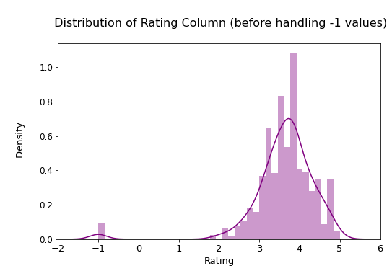
The data preparation phase involves a series of steps to transform and preprocess the data. The data preparation was not necessary for this dataset as the data was prepared nicely. Though after the first analysis I saw there were some values that were not very realistic, so I had to clean the data a little bit. This cleaning was mainly dealing with the minus values in the rating different companies had. On the website there were general ratings given out to all the companies but some companies had a -1 which obviously is not possible if a rating has to be given between 1-5 stars. Furthermore, to compare create a map of the locations of the jobs I had to use another dataset. To combine these two datasets I had to integrate the dataset containing the states into my main dataset.

Modeling
In this project, I am focusing on using data visualization techniques to understand the data and share my findings effectively. Instead of using traditional methods to make predictions or describe the data, I used visuals to see patterns, trends, and relationships.
By using data visualization, I want to find meaningful insights and share them in a way that is easy to understand. This helps me see the big picture and communicate my findings clearly and accurately.

Evaluation and deployment
As there was no use of machine learning the only thing I had to evaluate was the readability of my findings. I also did not go through the deployment phase because this model wont be put into real world systems it is only for my view on the data science sector

The analysis
The analysis of data science job opportunities across different states reveals interesting insights about the distribution of employment in the field. Here is a closer examination of the findings:
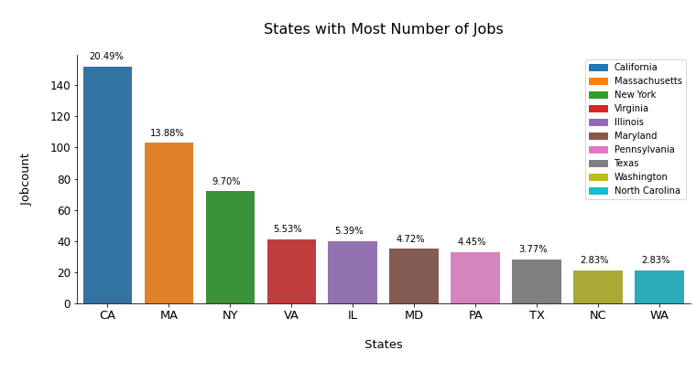

California's Dominance: It comes as no surprise that California has the highest number of jobs. With its renowned Silicon Valley and the concentration of tech companies, the state has established itself as a hub for technological innovation. The presence of major industry players and a thriving startup ecosystem contribute to California's position at the forefront of data science employment.
Massachusetts' Tech Transformation: The ranking of Massachusetts as the second state with significant job opportunities in data science aligns with the Milken Institute's State and Technology Index. This highlights the state's successful evolution into a tech-driven economy. Massachusetts has cultivated an environment conducive to technological advancement, attracting companies and fostering a skilled workforce, resulting in a notable growth of data science jobs.
New York's Unexpected Position: Despite being home to the largest number of Fortune 500 company headquarters, New York's placement in the third position for data science jobs is intriguing. While the state boasts a strong business landscape, the competition from California and Massachusetts in the tech sector appears to have impacted its relative ranking. This finding underscores the specialization of different regions and how certain states excel in specific industries.
Regional Distribution: The collective employment of California, Massachusetts, New York, and Virginia accounting for approximately 50% of the data science jobs signifies the concentration of opportunities in specific regions. These states have clearly emerged as key players, attracting talent and investment in the field. This concentration suggests that data science professionals may benefit from exploring opportunities in these regions due to the availability of diverse roles and a supportive ecosystem.
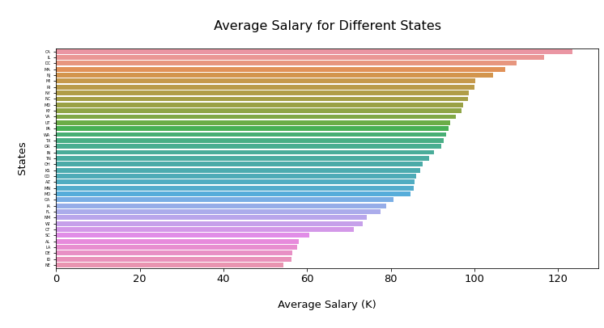
The analysis of average annual salaries for data scientists across different states reveals interesting patterns and disparities in compensation. Here is a closer examination of the findings:
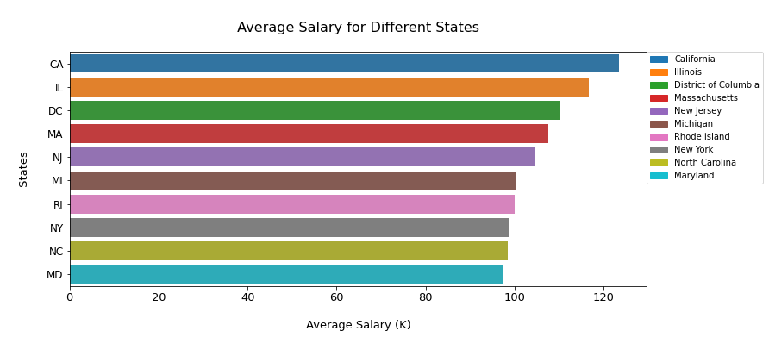
California's Salary Dominance: The data indicates that California offers the highest average annual
salary for data scientists. This can be attributed to several factors, including the presence of
renowned tech companies, such as those in Silicon Valley, which often offer competitive salaries to attract top talent. The abundance of job postings, specifically 74 positions mentioned, further
supports the notion that California provides lucrative opportunities for data scientists.

Illinois' Competitive Compensation: Following closely behind California, Illinois stands out as the
second state with a relatively high average annual salary for data scientists. While the specific reasons for this may vary, it is likely influenced by the state's robust tech industry and the presence of
prominent companies and research institutions that require skilled data science professionals.

Maryland's Lower Salary: The analysis reveals that Maryland has the lowest average annual salary among the states considered. This can be attributed to a combination of factors, including a lower number of job postings compared to other states and the distribution of job titles with varying salary ranges. The presence of both high-paying and lower-paying positions may contribute to the lower
average salary overall.

Disparity in Salary Comparisons: The analysis indicates a significant gap between the average salary of California and several other states, such as Alabama, Delaware, South Carolina, Idaho, Louisiana, and Nebraska. California's average salary being twice as high as these states suggests a considerable
difference in compensation levels and economic factors between regions. It highlights the importance of considering the regional context and cost of living when assessing salary figures.

Conclusion
The analysis of data science job opportunities and salaries across different states
provides valuable insights for beginners and experienced professionals in the field. In my opinion the number of jobs is more important to a beginner as they are inexperienced and they will likely not be chosen over very experienced professionals. The opposite is true for the experienced professionals. This has been taken into account while making a conclusion.
For beginners, the most attractive state would be California. With its high concentration of tech
companies and the renowned Silicon Valley, California offers abundant job opportunities, which is a critical factor for those starting their careers. Although salary may be less important at this stage,
California still provides competitive compensation and the potential for career growth.
For experienced professionals, salary becomes the primary consideration. In this case, California
remains an appealing choice due to its highest average annual salary for data scientists. However, other factors come into play as well. Illinois emerges as a competitive option with a relatively high
salary and a thriving tech industry. Experienced professionals may also consider factors like the cost of living and the specific industry or specialization they wish to pursue.
In summary, California stands out as the most attractive state for both beginners and experienced professionals, offering a strong combination of abundant job opportunities and high salaries.
However, Illinois presents a compelling alternative for experienced professionals, with its competitive compensation and thriving tech sector.

